# Appendices

Appendix A: Dream 11 Point Tables

1. Score Point Table:

|  |  |  |
| --- | --- | --- |
| **Notation** | **Type of Points** | **Weight** |
| φMatches | Being a part of the starting XI | 4 |
| φRuns_Scored | Every run scored | 1 |
| Φctchs | Total catches taken | 8 |
| Φfifties | Total number of 50s scored | 8 |
| Φhundreds | Total number of 100s scored | 16 |
| Φnum_4s | Total number of 4s scored | 1 |
| Φnum_6s | Total number of 6s scored | 2 |
| φstmp | Stumping/ Run Out (direct) | 12 |
| Φr_out | Run Out (Thrower/Catcher) | 8/4 |
| Φfduck | Dismissal for a Duck (only for batsmen, wicket-keepers and all-rounders) | -2 |
| Φbat_innings | Number of times a player has batted in a match |  |
| Φbowl_innings | Number of times a player has bowled in a match |  |
| Φwickets | Number of wickets taken by a bowler in the season | 25 |
| Φmaidens | Number of times a bowler has bowled an over without conceding any runs | 8 |
| Φ4_wicket_houl | Number of times a player has taken 4 wickets in a single match | 8 |
| Φ5_wicket_houl | Number of times a player has taken 5 wickets in a single match | 16 |
| Φbowl_economy | Bowling economy of a player |  |
| Φbat_strike_rate | Batting Strike Rate of a player |  |
| Φmax_matches | Maximum matches played by a team |  |

### b. Bonus Points:

|  |  |
| --- | --- |
| **Type of Points** | **Weight** |
| Every boundary hit | 1 |
| Every six-hit | 2 |
| Half-Century (50 runs scored by a batsman in a single inning) | 8 |
| Century (100 runs scored by a batsman in a single inning) | 16 |
| Maiden Over | 8 |
| 4 wickets | 8 |
| 5 wickets | 16 |

### Economy Rate:

|  |  |
| --- | --- |
| **Type of Points** | **Weight** |
| Minimum overs bowled by a player to be applicable | 2 overs |
| Between 6 and 5 runs per over | 2 |
| Between 4.99 and 4 runs per over | 4 |
| Below 4 runs per over | 6 |
| Between 9 and 10 runs per over | -2 |
| Between 10.01 and 11 runs per over | -4 |
| Above 11 runs per over | -6 |

### Strike Rate:

|  |  |
| --- | --- |
| **Type of Points** | **Weight** |
| Minimum balls faced by a player to be applicable | 10 balls |
| Between 60 and 70 runs per 100 balls | -2 |
| Between 50 and 59.99 runs per 100 balls | -4 |
| Below 50 runs per 100 balls | -6 |

Appendix B: Analytical Hierarchy Process Scale Table

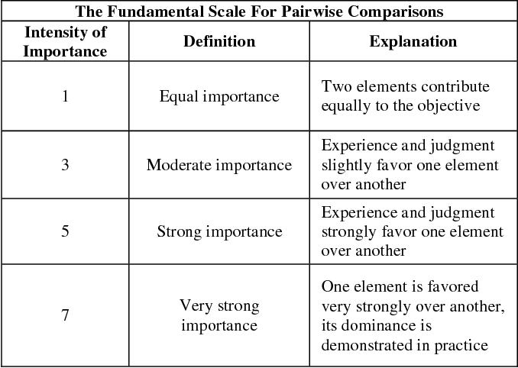

Appendix C: Hyperparameters used for training our model

1. Hyperparameters for Logistic Regression

|  |  |
| --- | --- |
| penalty | l2, l1 |
| solver | liblinear |
| max_iter | 100, 200, 300, 400, 600, 900, 1200, 1500, 1800, 2100 |
| tol | 0.0001, 0.00001, 0.0005, 0.001, 0.1, 0.5, 1 |
| C | 1.0, 1.5, 2, 1.25, 1.75, 3, 4, 5, 7, 9 ,12 |

1. Hyperparameters for Support Vector Machines

|  |  |
| --- | --- |
| Kernel | rbf |
| Gamma | 1, 0.1, 0.01, 0.001, 0.0001 |
| C | 0.1, 1, 10, 100, 1000 |

Hyperparameters for Knn

|  |  |
| --- | --- |
| n-neighbors | 1, 3, 5,6, 8, 10,12, 14, 15, 18 |
| Weights | uniform, distance |
| Metric | euclidean, manhattan, hamming |
| Leaf_Size | 10, 15,20, 25,30 |

1. Hyperparameters for Adaboost

|  |  |
| --- | --- |
| learning_rate | 0. 005 ,0.01 ,0.02, 0.05,0.15, 0.5, 0.1,1 |
| n_estimators | 10,20,50,100,200,800,1000 |

1. Hyperparameters for XGboost

|  |  |
| --- | --- |
| learning_rate | 0.05, 0.10,0.15, 0.25 |
| n_estimators | 50,100,200,500,700,1000 |
| max_depth | 4,5,6,7,8 |
| gamma | 0,0.1, 0.2,0.3 |
| min_child_weight | 1,3 |
| colsample_bytree | 0.3, 0.4, 0.7 |

1. Hyperparameters for ExtraTreeClassifier

|  |  |
| --- | --- |
| n_estimators | 100,200,600,900,1200,1500,1800,2100 |
| max_depth | 3,4,5,12,15 |
| max_features | Sqrt, log2 |
| min_sample_leaf | 3,5,8,12 |

1. Hyperparameters for RandomForestClassifier

|  |  |
| --- | --- |
| bootstrap | True, False |
| max_depth | 3,4,5,6,7 |
| max_features | 0.5, 'sqrt','log2' |
| min_samples_leaf | 2, 4 |
| min_samples_split | 2, 5 |
| criterion | Gini, entropy |
| n_estimators | 800,1000,1200,1600,2000 |